User persona: [YOUR COMPANY]
Company/org description:

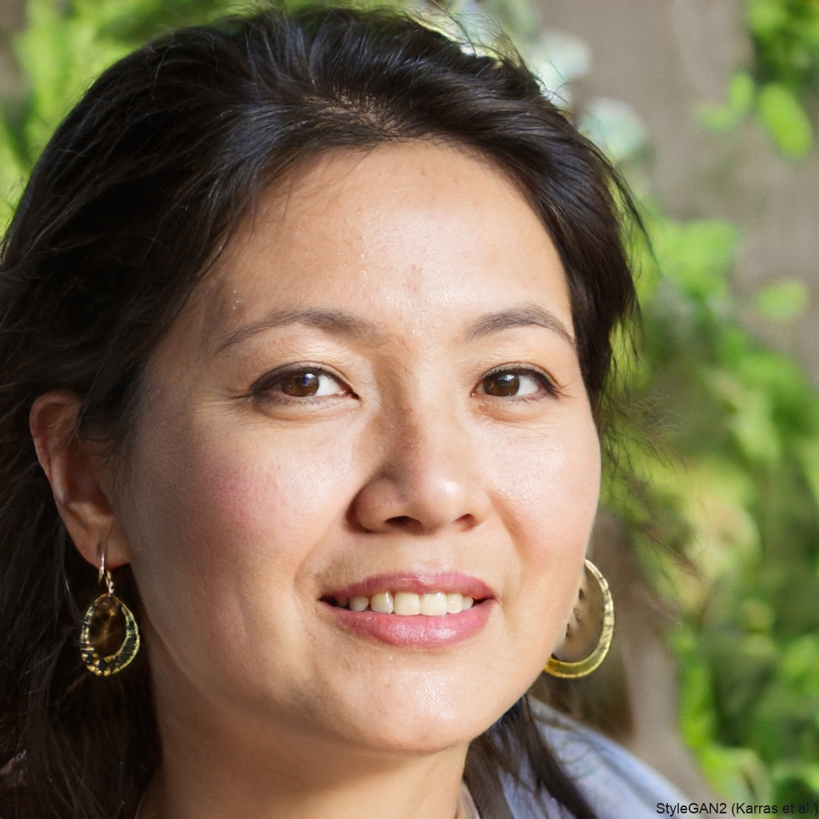
Basic persona information
Name:
Age:
Gender:
Occupation:
Location:
Education level:
Income range: $ per year

Background info
- Brief personal history:
- Family status:
- Hobbies/interests:
- Values:

Goals and motivations
- Primary goal:
- Secondary goals:
- What motivates them?
- What are their aspirations?

Challenges and pain points
- Main challenges:
- Frustrations:
- Obstacles they face:

Behavior patterns
- Online habits:
- Social media usage:
- Preferred communication channels:
- Shopping behavior:
- Decision-making process:

Technology usage
- Devices owned:
- Preferred apps/platforms:
- Tech-savviness level:

Information sources
- Where do they get them news/information?
- Trusted brands/influencers:
- Preferred content formats:

Relation to TechEase Solutions
- How do they currently interact with the company?
- What products/services are they interested in?
- What needs does the company fulfill for them?

Scenarios
- Scenario 1:
- Scenario 2:

